Why is bit-banging impractical on your laptop, despite it having a much faster processor than the RP2040?

3.3

ws2812.c

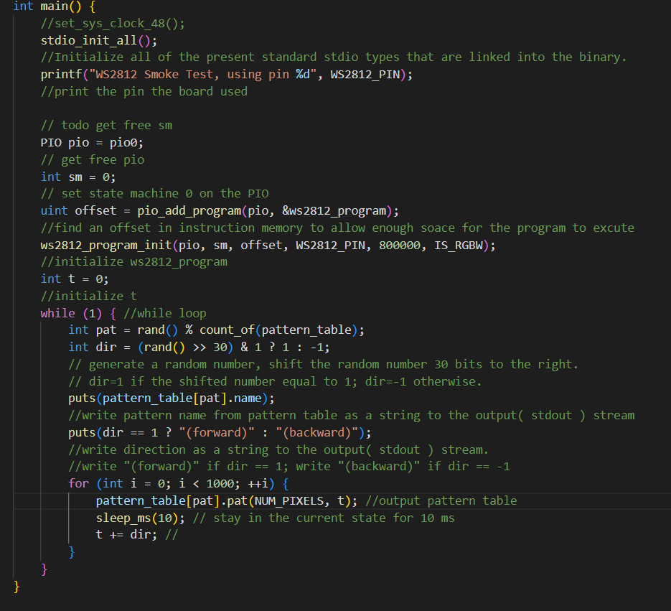

generated/ws2812.pio.h

